**Requirement Gathering and Analysis Phase**

**Data Flow Diagram & User Stories**

|  |  |
| --- | --- |
| Date | 25 June 2025 |
| Team ID | LTVIP2025TMID59707 |
| Project Name | Project – House Hunt |
| Maximum Marks | 50 Marks |

**Data Flow Diagrams:**

A Data Flow Diagram (DFD) is a traditional visual representation of the information flows within a system. A neat and clear DFD can depict the right amount of the system requirement graphically. It shows how data enters and leaves the system, what changes the information, and where data is stored.

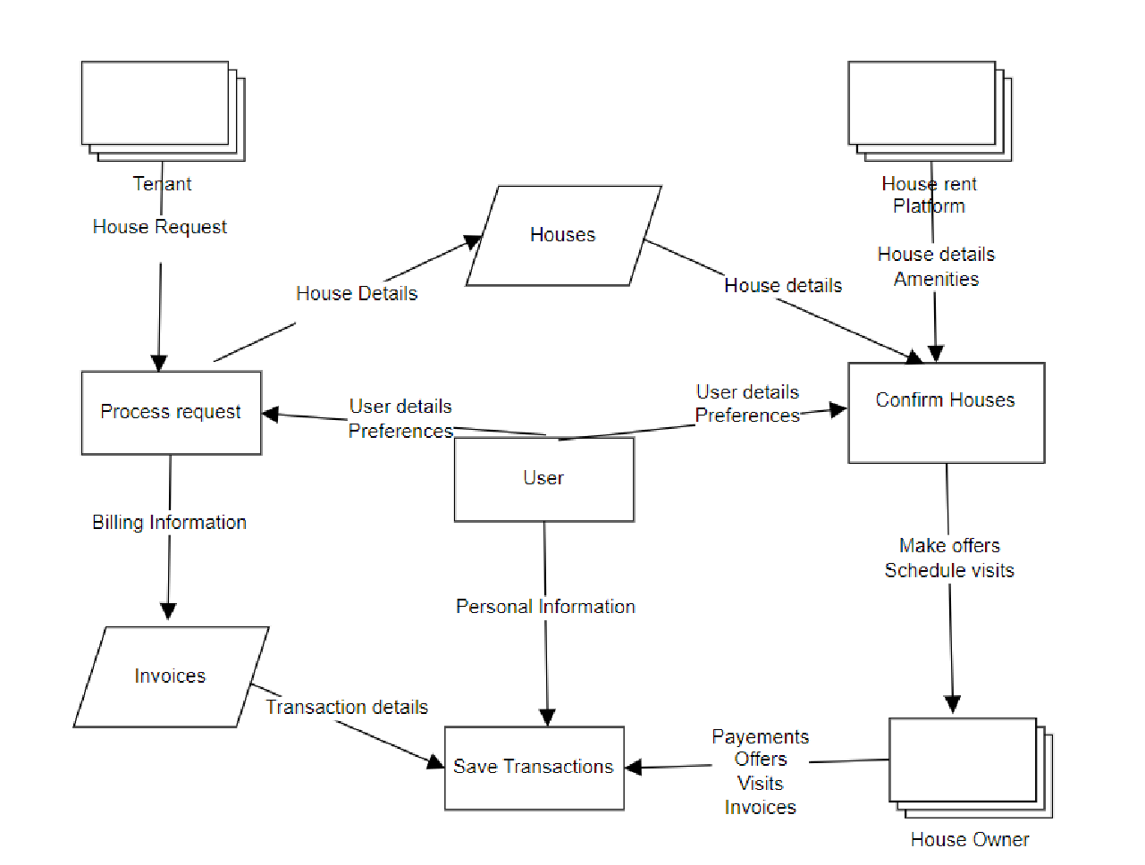

**User Stories** DFD Level 0 House rent

**User Type Functional User User Story / Task Acceptance criteria Priority Release Requirement Story**

**(Epic) Number**

Tenant Registration USN-1 As a user, I can register for the application I can access my account High Sprint – 1

(Mobile user) by entering my email, password, and / dashboard

confirming my password.

USN-2 As a user, I will receive confirmation I can receive Medium Sprint – 2

email once I have registered for the confirmation email &

application click confirm

USN-3 As a user, I can register for the application I can register & access Low Sprint – 3

through LinkedIN the dashboard with

LinkedIN Login

Tenant User USN-4 As a user, I can receive confirmation via I can confirm my Medium Sprint-2

(Mobile user) Confirmation email account by verifying via

email

USN-5 As a user, I can register confirmation via I can confirm my High Sprint-1

OTP. account by verifying via

OTP

T enant and Profile USN-6 As a user, I can update my personal I can update my Low Sprint – 3

Owner Management information. personal information

(Mobile user)

USN-7 As a user, I can change my password I can change my High Sprint – 1 passwords

USN-8 As a user, I can set preferences for I can decide if I want to Low Sprint – 3

notifications and alerts. receive notifications

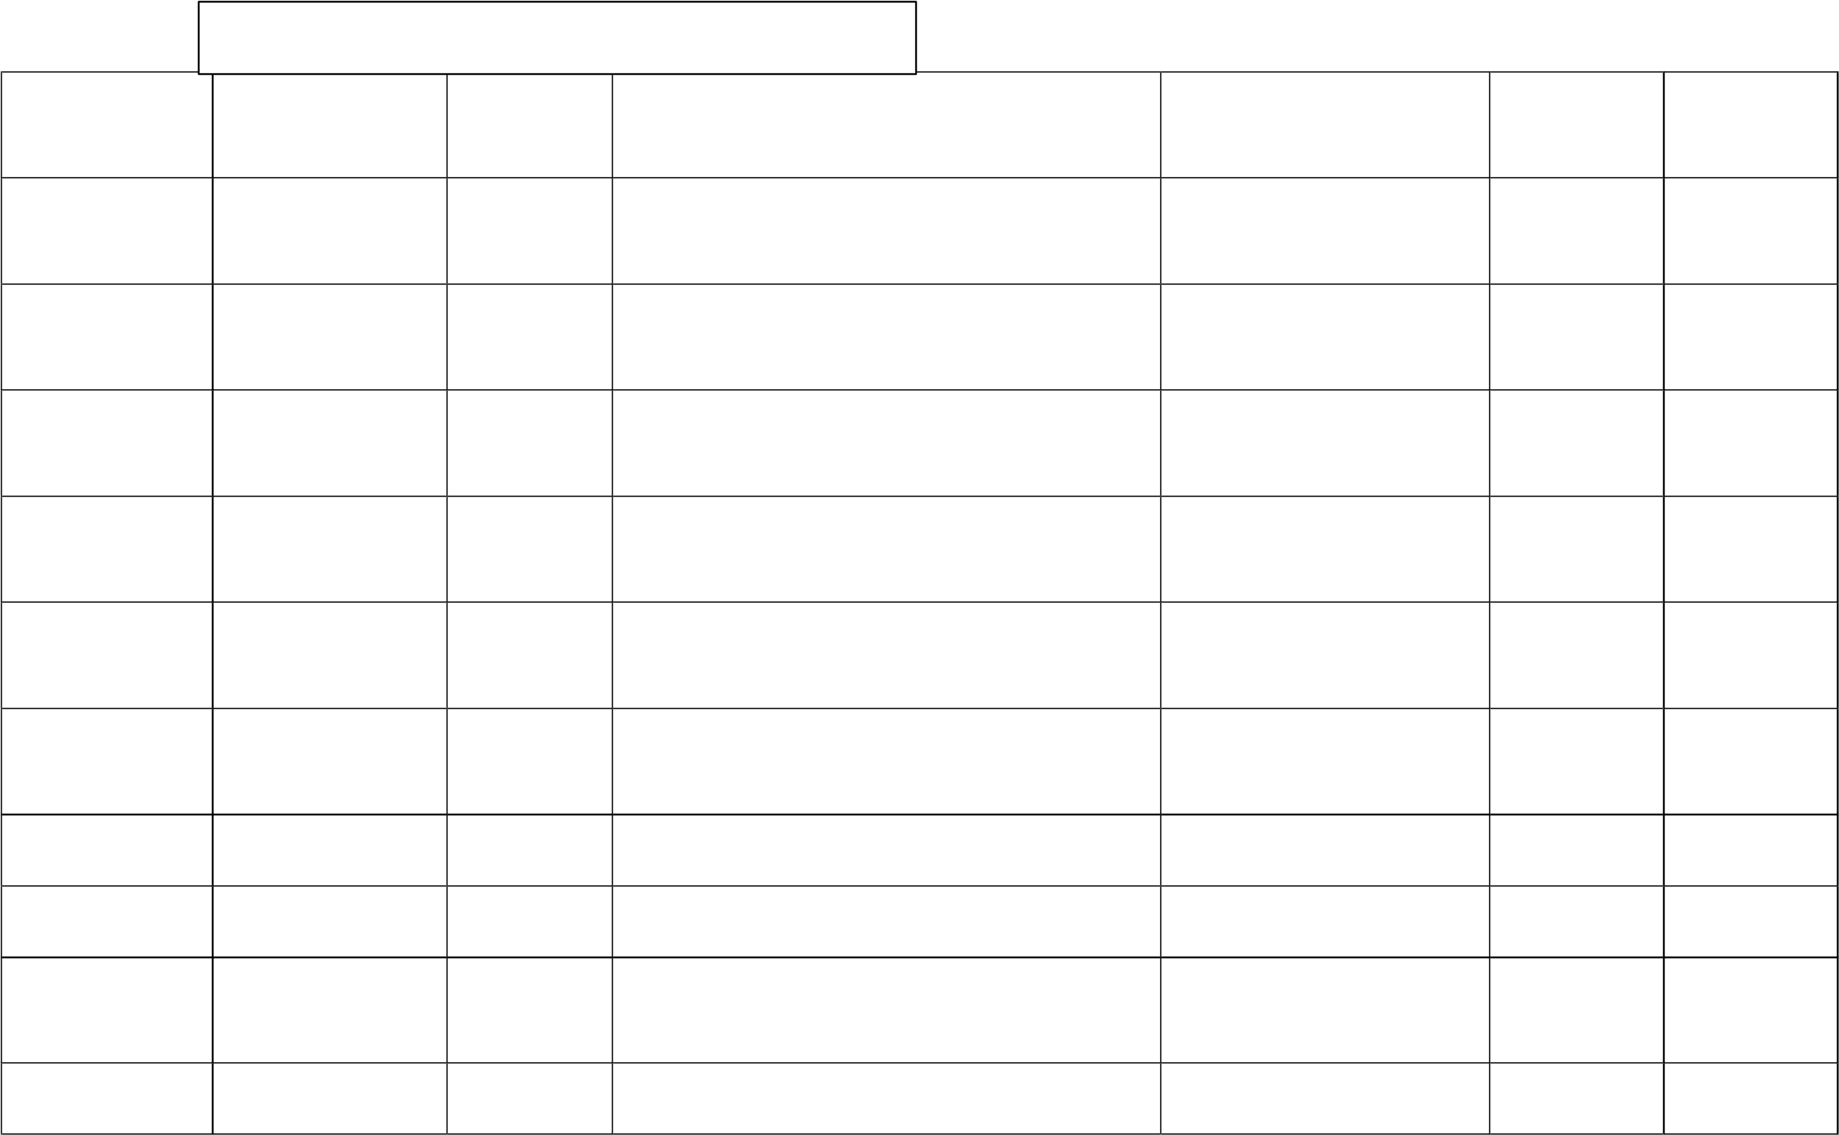Tenant Browsing and USN-9 As a user, I can perform a basic search, I can search by applying Medium Sprint – 2 (Mobile user) searching apply filters, and view results on a map. filters based on the requirements

USN-10 As a user, I can create favourites and I can shortlist my Medium Sprint – 2

shortlists, and view market trends. favourite houses

|  |  |  |  |  |  |  |
| --- | --- | --- | --- | --- | --- | --- |
| **User Type** | **Functional**  **Requirement (Epic)** | **User**  **Story**  **Number** | **User Story / Task** | **Acceptance criteria** | **Priority** | **Release** |
|  |  | USN-11 | As a user, I can view nearby amenities. | I can verify and enquire about nearby amenities | Low | Sprint - 3 |
| Tenant and  Owner  (Mobile user) Admin (Web  user) | Communication | USN-12 | As a user, I can use messaging and schedule appointments. | I can schedule house visits | High | sprint – 1 |
|  |  | USN-13 | As a user, I can share documents and receive transaction updates. | I can manage Invoices and transaction details | Low | Sprint – 3 |
| Owner  (Mobile user) | Property Listing | USN-14 | As a user, I can upload photos and videos, and add property features and amenities. | I can upload photos of my property | Medium | Sprint – 2 |
|  |  | USN-15 | As a user, I can access legal and disclosure information, and negotiate offers. | I can access legal information and negotiate offers | High | Sprint – 1 |